CARB Cell 1 Enterprise Demo
STARS VETS - UDP Driver Setup

- Expand the “Remote Automation Interfaces” node in the hardware inventory. Right click and select New -> STARS UDP Interface.

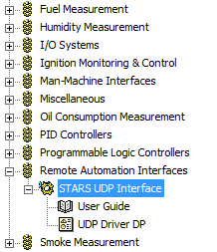

- Copy the UDP driver from the hardware inventory and paste it into the test stand.

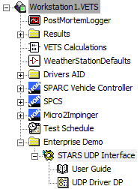

- Check the configuration settings of the driver by right clicking and selecting edit. Put the device in Writer mode. Set the IP address such that it matches the local address of the receiving machine (which UDP packets are being sent to), and set the port number such that it matches an open UDP port on the receiving machine (‘netstat –a’ can be used to search for open ports via cmd on windows machines). Set the frequency to an appropriate value and enable Auto-start. Set simulation, use RTX network stack, ASCII protocol, byte order, and frame counter as desired.
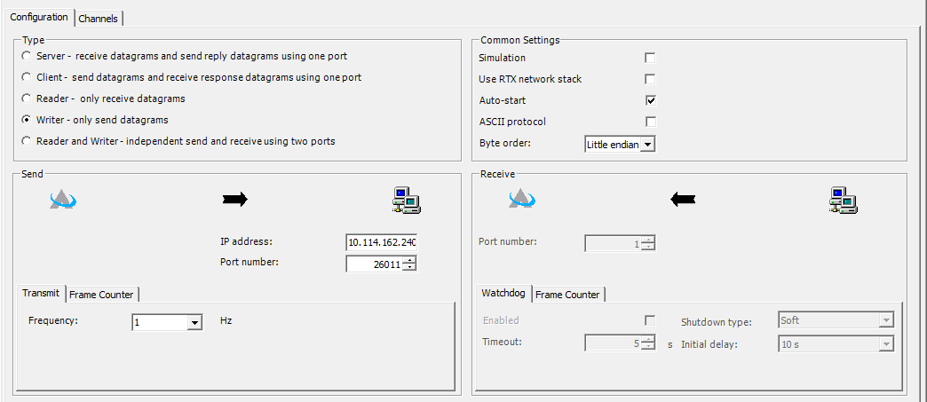
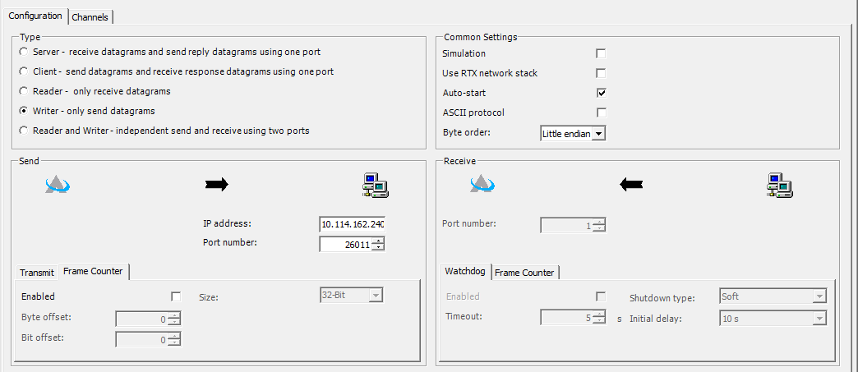

- Select the channels tab. Add channels to the outputs section by right clicking and selecting “Add Output Channel”. Ensure that each output channel has a quantity of “Real Number”, a unit of “Real”, is enabled, has a data type of “Real 64-Bit”, a data byte offset of N*8 where N is the channel number (with iteration starting at 0), and a data bit offset of 0. An output channel can be tied to a standard name, such that the value of the standard name will be sent over that channel.
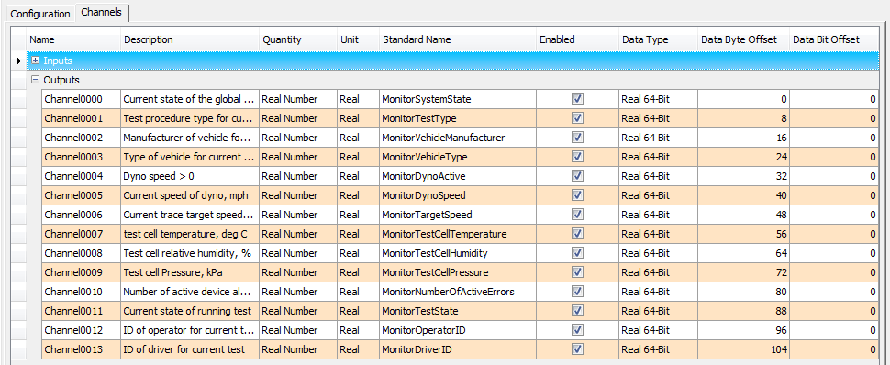
- New standard names can be created for the purposes of tying to the UDP driver by selecting Tools -> Standard Names, then right clicking and selecting “New Standard Name”. Ensure that any standard name which will be tied to an output channel has a quantity of “Real Number”, display units of “Real”, and is not Hidden.
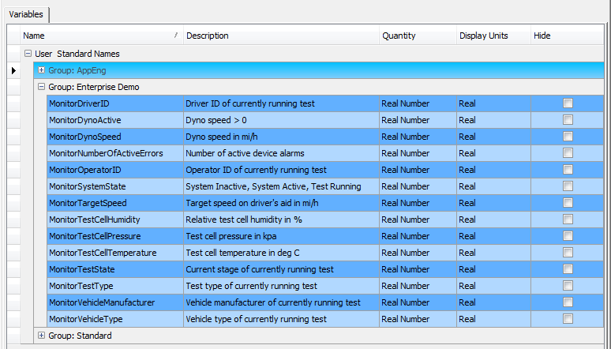
- Once connected, the UDP driver should begin sending frames. Check that frames are being sent by double clicking on the “UDP driver DP” display page.
